1.Create device on IBM Watson IOT Platform

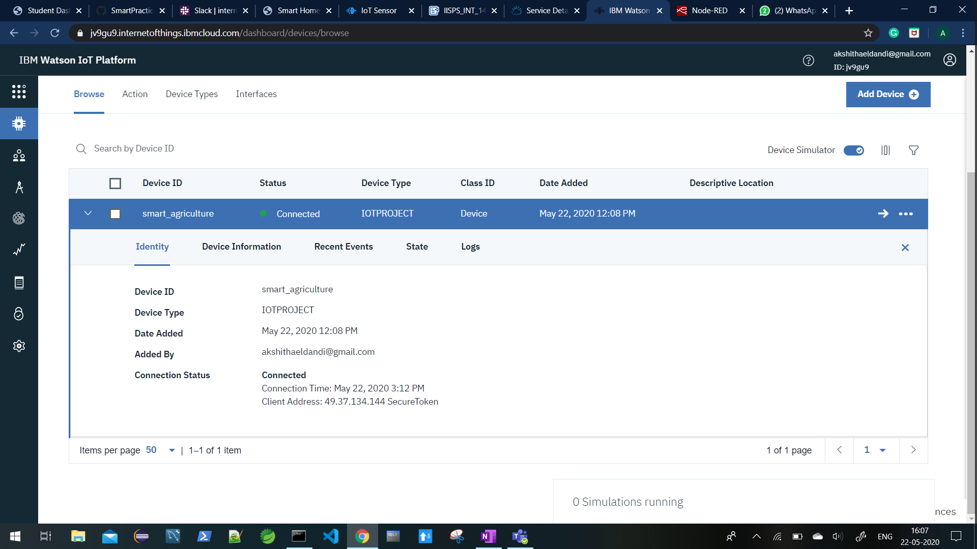

2.Created simulation device by adding payload as below

{

"Temperature": random(0, 100) ,

"Humidity": random(0, 100) ,

"Object temperature": random(0, 100) }

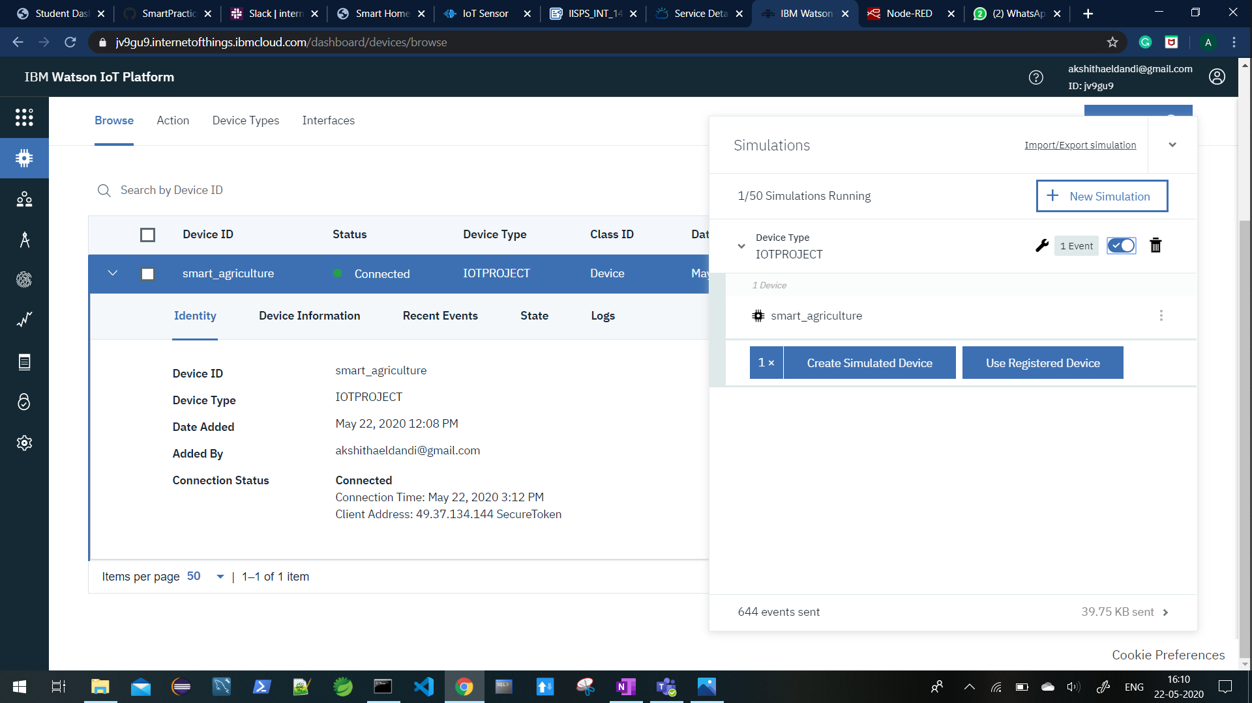

3.When we start a simulation, accordingly events will be displayed for every minute(I set my simulator to display 20 events every minute).

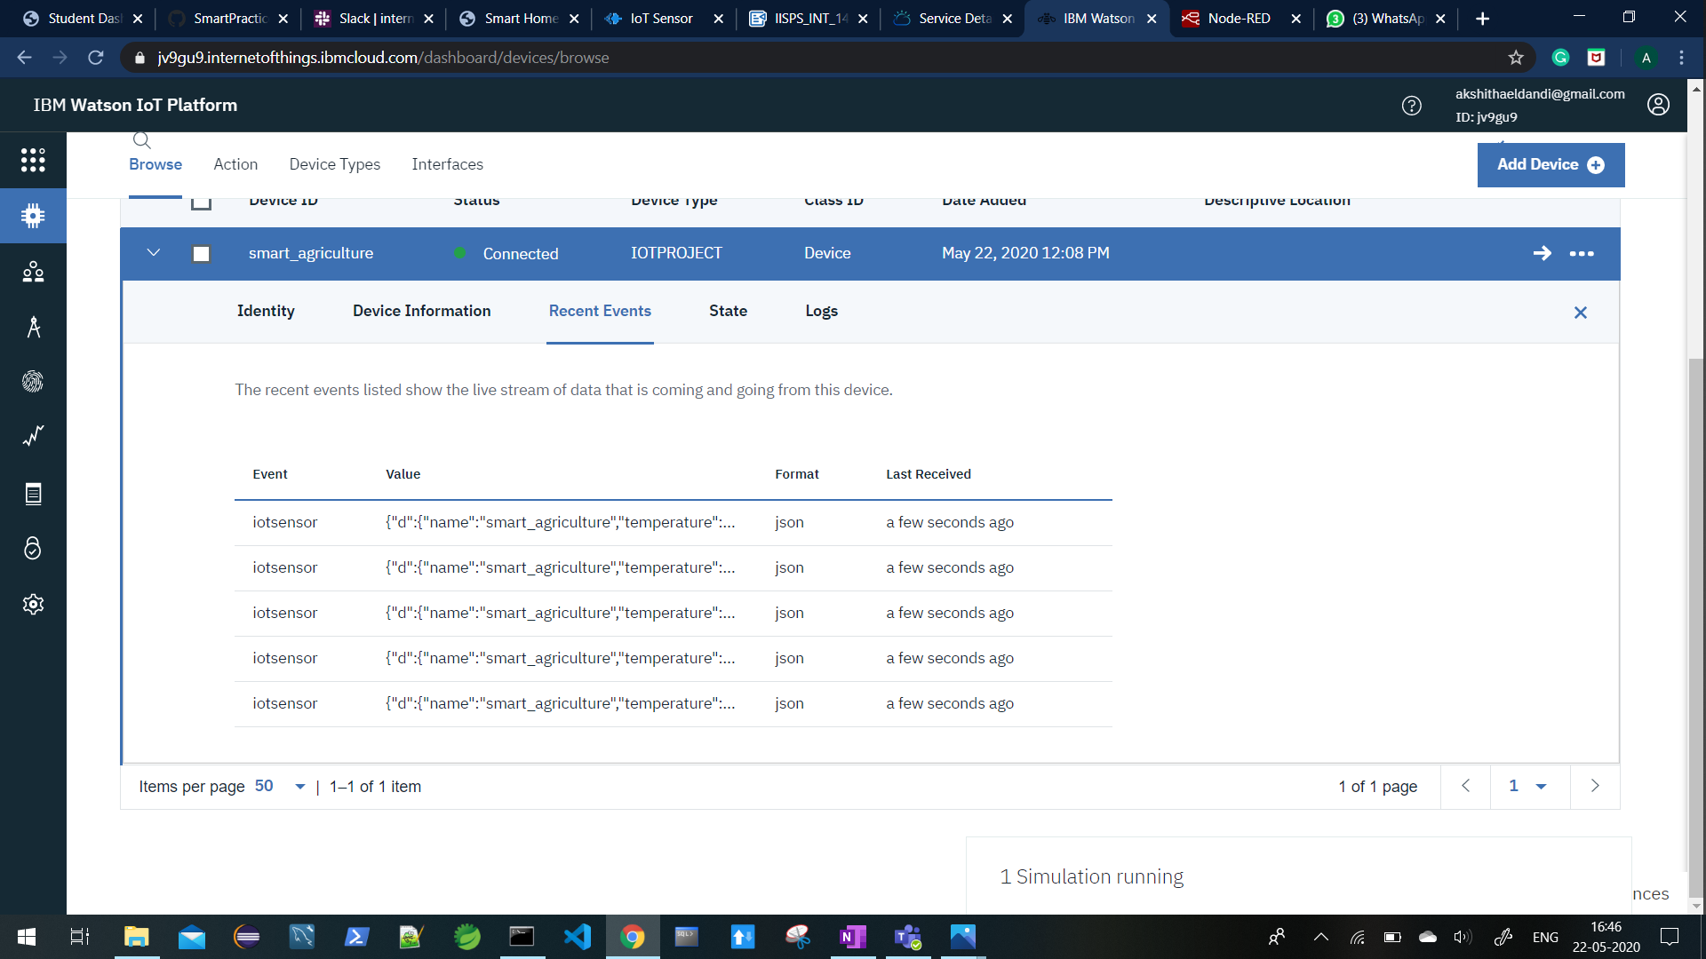

4.Created API Key

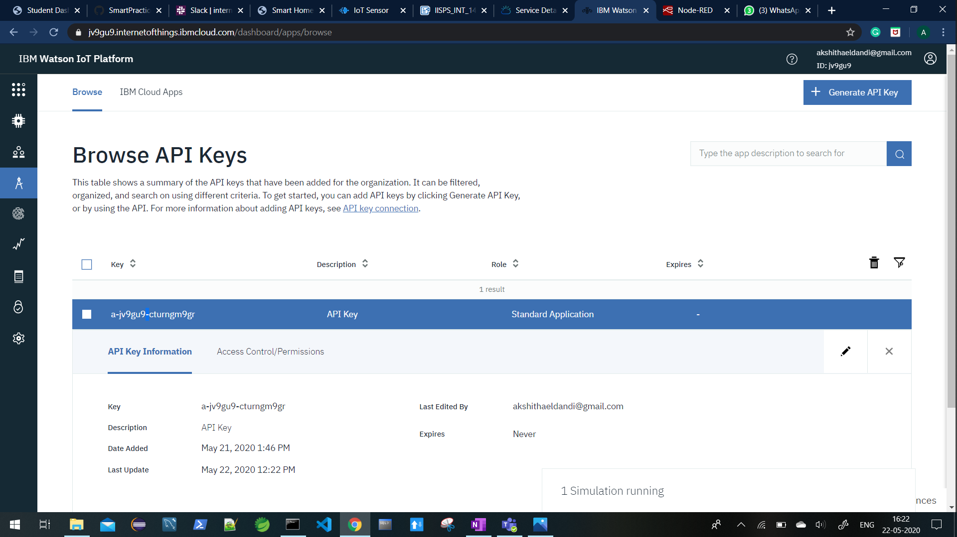

5.Created Cards in Board

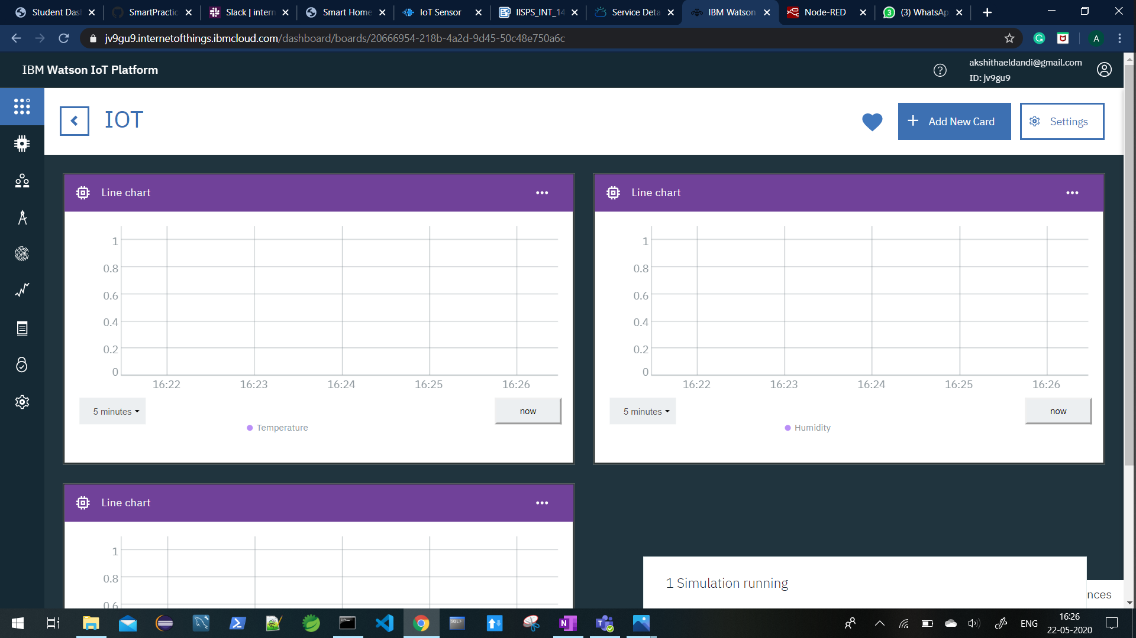

6.Connected Device to Watson IOT simulator

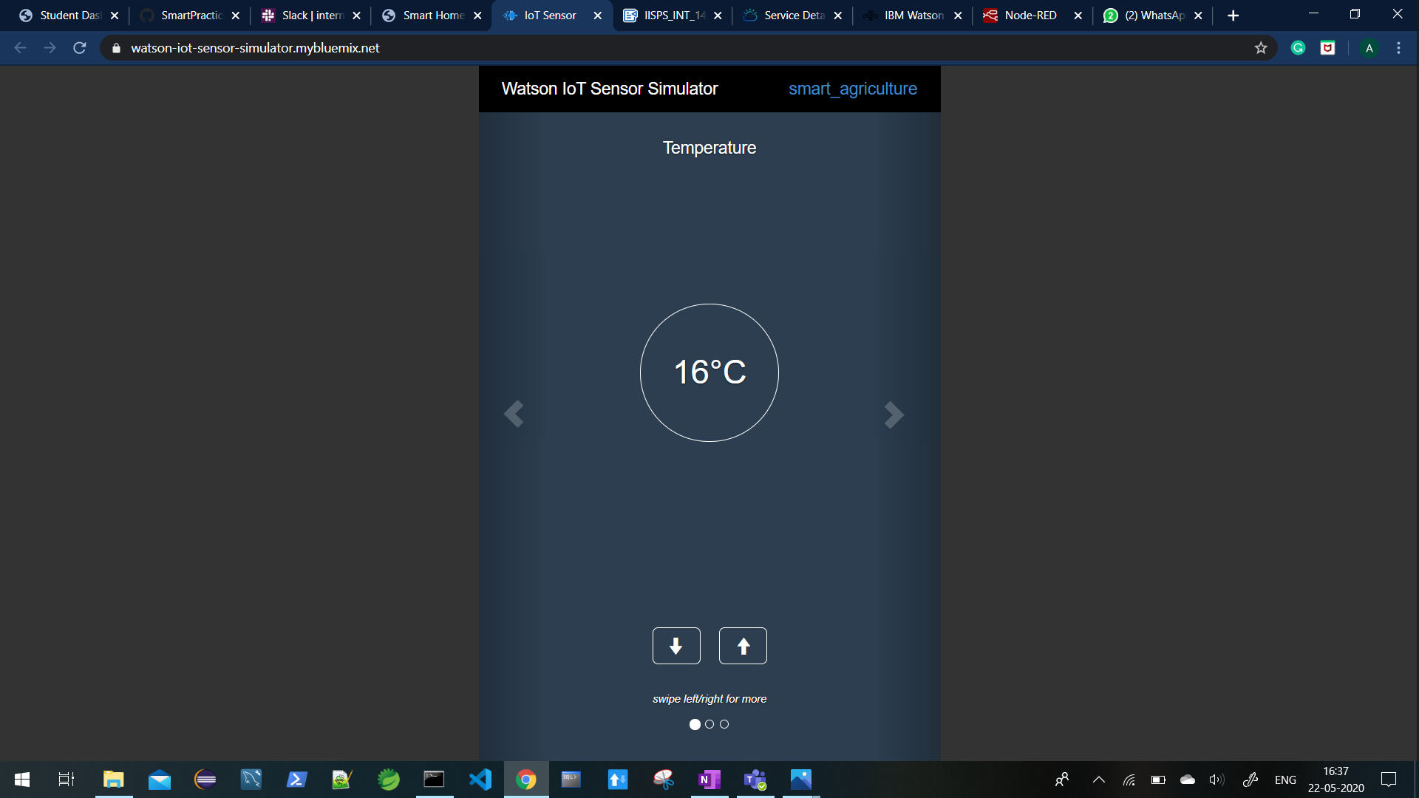

7.Add the IBM IOT node and give our device Id and device type and also add API key that we have generated in the IBM Watson IOT Platform and the debug node to Node-red and connect them

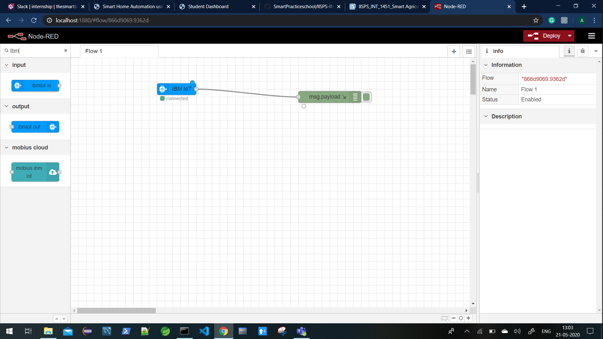

8.Now when we click the deploy button debug messages are displayed on right side console

